Prepare Yourself for a Lifetime of Discovery!
The Outdoor Trip Leader Program (TLP) prepares NMSU Students to plan, implement and lead outdoor recreation and/or cultural programming for the NMSU Student body. We seek highly motivated Students who wish to enrich their college experience by developing their technical and leadership skill sets. Participants receive training in group dynamics, teaching techniques, risk management, wilderness first aid, Leave No Trace ethics, and outdoor skills during a mandatory Trip Leader Training Session. Successful Adventure Trip Leaders will be employed by University Recreation and assigned trips/events/clinics based on their skills and abilities. The Outdoor Adventure Program equips its Student employees with practical leadership experiences to complement their academic degrees and give them the edge in the job market after graduation. Get the most out of your college years, challenge yourself, and apply today on NMSU Handshake!
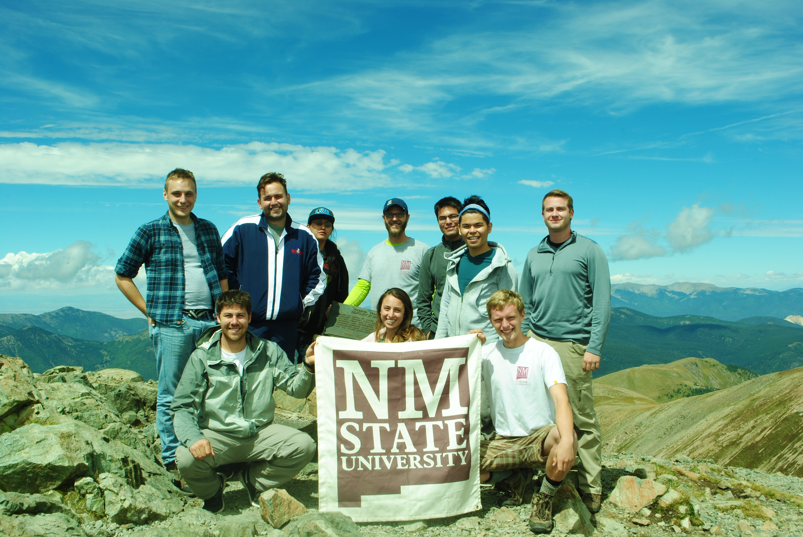
UREC Adventure Trip Leader Job Posting

Trip Leader Training Session Structure
All selected applicants will be invited to attend a mandatory Orientation on March 7th at 6pm and will begin preparing for the mandatory Trip Leader Training Session. The Spring 2023 Trip Leader Training Session is March 10th -15th. Exceptions include those with extensive previous experience in the outdoors, professional certificates, and the ability to test-out of evaluations.

Trip Leader Training is designed to provide an environment where the Cohort can learn and demonstrate relevant techniques and skills in situ:
- Introduce and integrate the new members as a Cohort;
- Introduce and familiarize the cohort with OAP PPM and UREC Code of Conduct;
- Deliver OAP curricula for Leadership & Facilitation, Outdoor Technical Skills, and LNT; and,
- Evaluate and certify OLP Cohort Members as Assistant Facilitators

Need More Challenge?
Those interested in leading backpacking, mountain biking, canoeing/kayaking, or climbing trips are offered additional skill-specific trainings, and can build towards becoming a Lead Instructor.

Applications Must Include:
- OAP Application Form
- Letter of Interest
- Resume

Optional Information Meeting:
January 19th @ 5:30pm
Room 103 of the Activity Center

Application Due Date – March 3, 2023.
Submit to antmcg79@nmsu.edu or via Handshake.

Want to know more before submitting you application? Come visit with the Program Coordinator in person, or via Zoom.
Outdoor Trips Program Coordinator
Anthony McGlone
Email Me! OR (575) 646-5150
Room 235 of the Activity Center.
Eligibility Requirements:
The Outdoor Adventure Program is physically, mentally, and emotionally demanding. In order to participate in the program, participants must acknowledge and meet the following:
- Current NMSU Main Campus Student in good standing with two semesters or more
- Maintain a cumulative 2.5 GPA or above.
- Must possess a valid and violation free driver's license.
- Lift, balance, and carry personal and group equipment between 35-50lbs.
- An interest in sharing outdoor and cultural experiences with other Students.

Please submit the following documents with this application form by March 3rd, 2023 to Anthony McGlone either in person or via email. A complete application includes this form AND ALSO:

- Cover Letter
- Resume

Selected Candidates will be contacted for an interview and given information about the Trip Leader Training Program.

Applicant Information
Name: __________________________________________________________________________
Current Address: ________________________________________ City: _____________________ State: _________ Zip: ______________ Phone: _________________________________________
NMSU Email: _______ __________________________ Aggie ID: ___________________________

Education
Year in School: _______________________ Expected Graduation Date: ______________________
Major: ________________________________________ GPA: ______________________________

Current Certifications, Experience, or Relevant Coursework 1._______________________________________________________________________________
2._______________________________________________________________________________
3._______________________________________________________________________________
4._______________________________________________________________________________
5._______________________________________________________________________________

Additional Background Information

Why are you interested in participating in the Outdoor Adventure Program?

Share any experiences personal or professional experiences that you believe relate to this program.

Explain what you would expect to gain from the program and how it will benefit you as an individual, or your community.

